- This is shows that consumed_tonnes is righ skewed with some days having nothing consumed, some having over 69 tonnes consumed. with an average consumed_tonnes hitting 23.7 tonnes
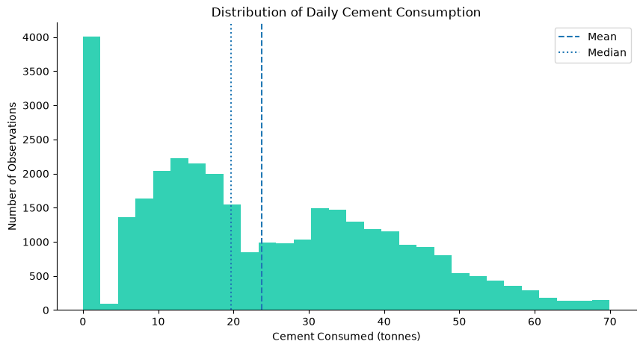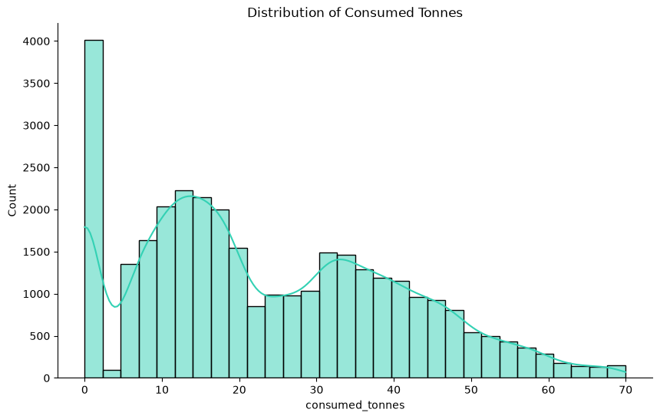

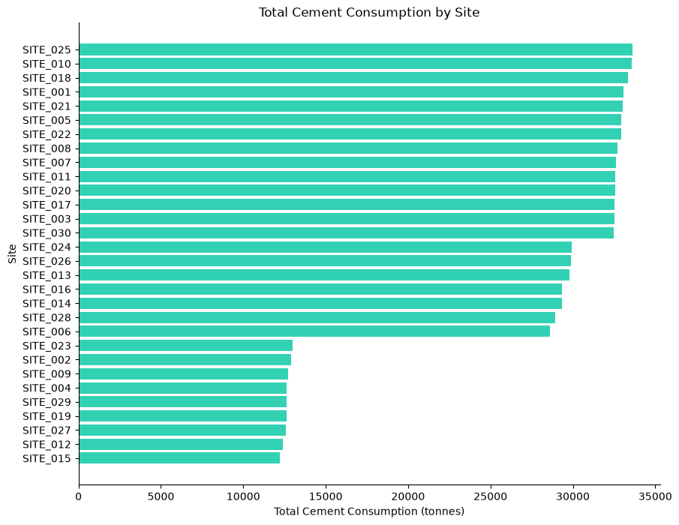
- The insight is telling, some site clearly show they dominate in daily consumption of tonnes which could be as a result of alot of factors

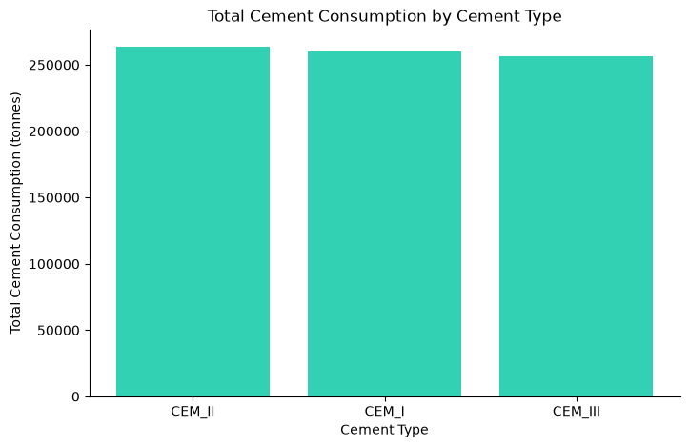
- These does not tell much about cement consumption by type. They all fairly consumed similarly amount. Let's look at the % share of the total consumption. This could tell much rather just looking at the absolute values
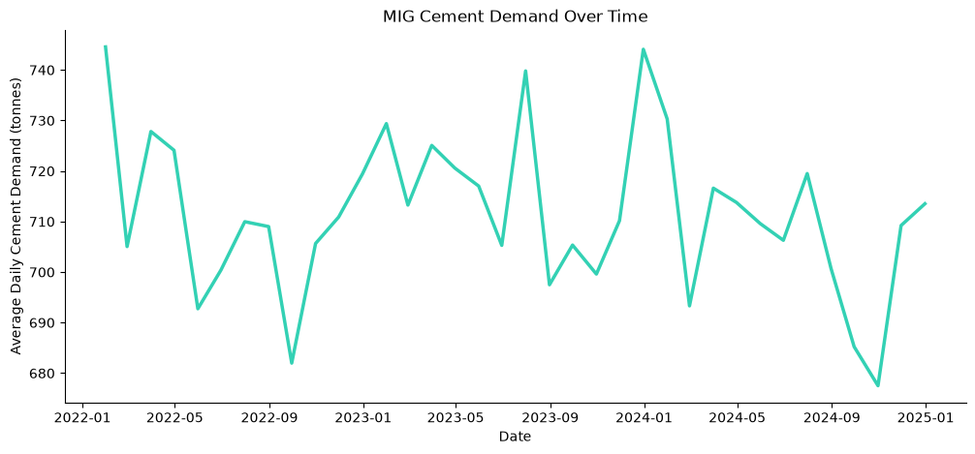
- There is clear fluctuation in daily cememt consumption over time. We look at this more later. let now look at the monthly trend
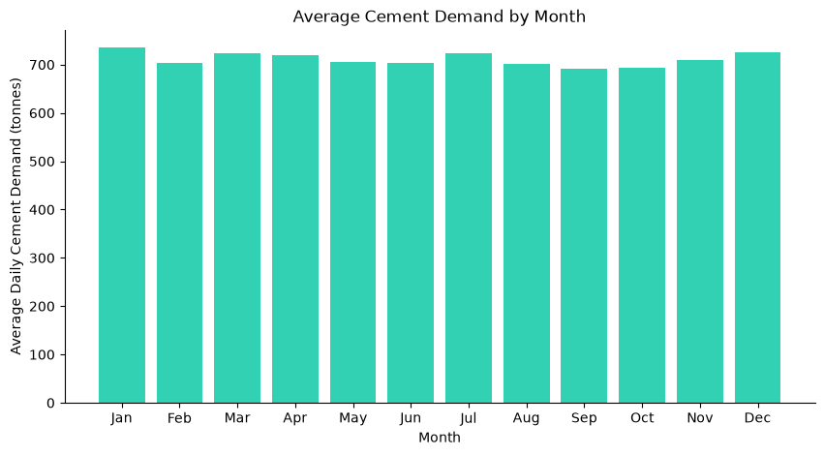
- Monthly cement consumption does not vary that much across months. Maybe weekly demand could tell more story
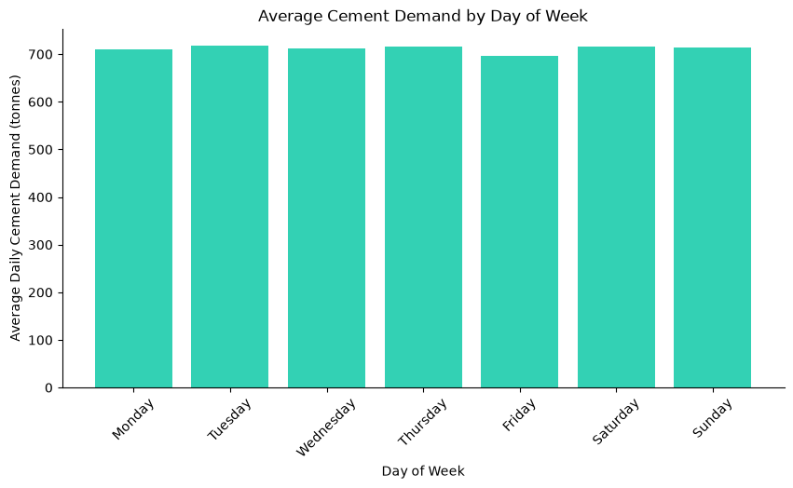
- Average demand on weekly basis is relatively almost the same across days of the week with no special spike or fall out. This could be due that fact that we are looking at the average consumption across time

- Even at that we can still spell out that demand is relatively higher on Tuesday, Wednesday, Thursday Saturday and Sunday and remotely not higher on Friday and Monday.
- Looking at the average does not really tell the story that much. This is because different Site might have same or slightly different average consumption but still differe by demand site. So to capture this effect. Let's look at Demand Volatality measured by (mean, std and coffiecient of variation)
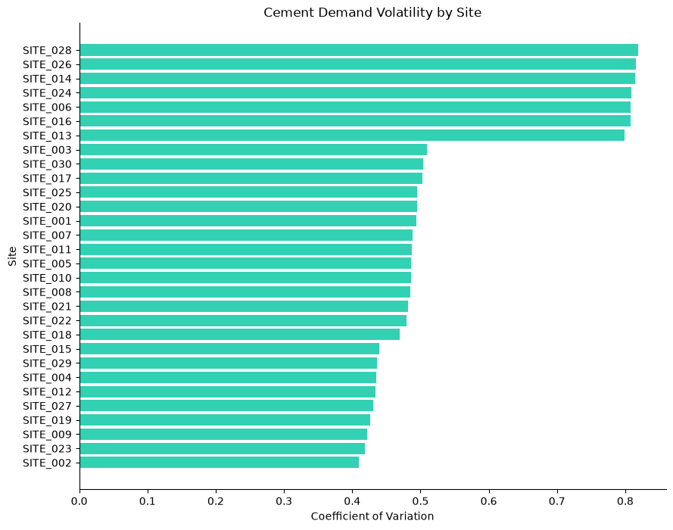
- One can say that Sites 28, 26, 14, 24 and 06 shows very volatal(that is variation in demand) while other Site depcits quiet predictable demand (less volatality)

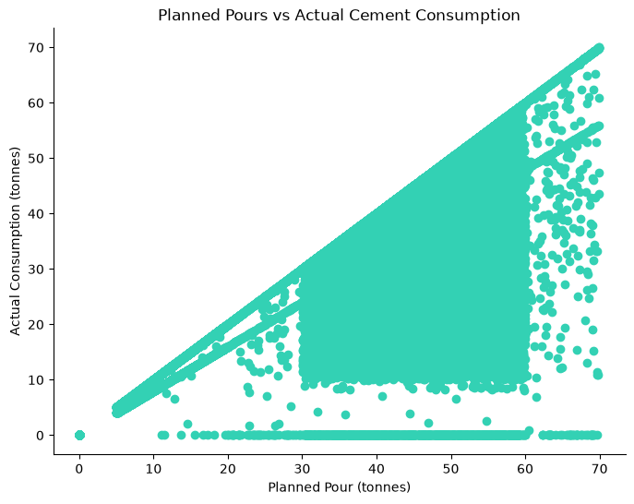
- This is there is a clear postive relationship between Planned Pour(tonned) vs Actual consumption. With a Correlation of 0.781. Although this does not in any way depicts casuation

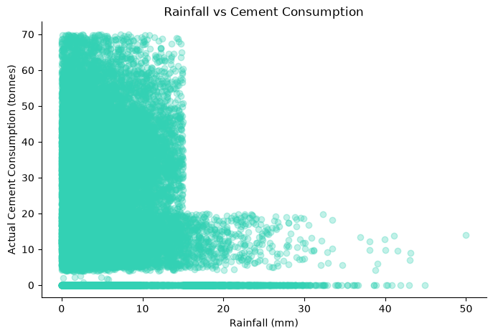
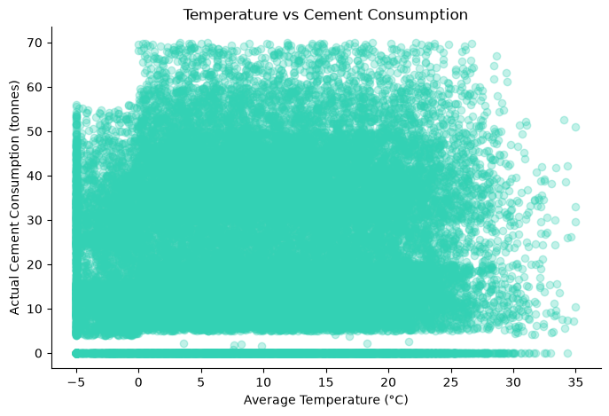
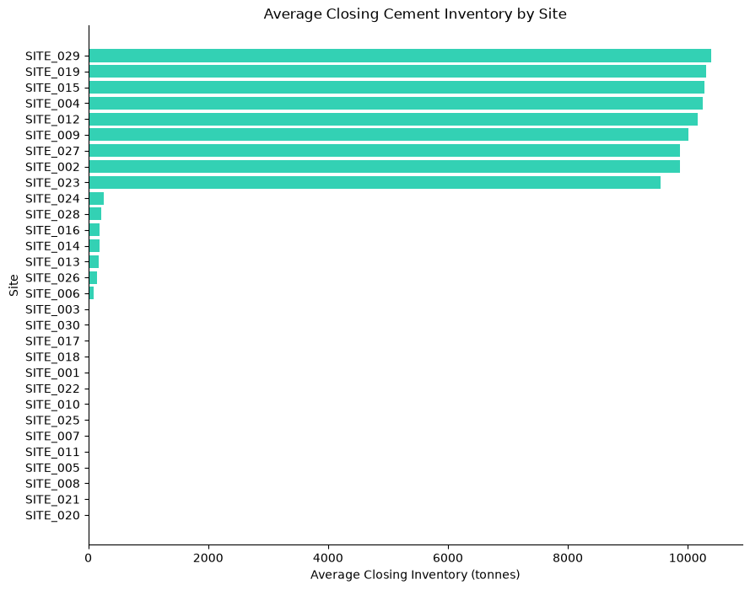
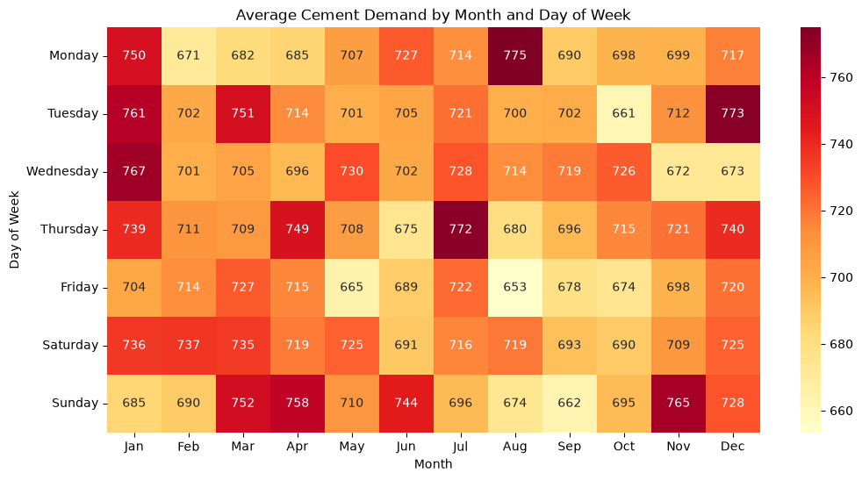
- We can see at glance the day of week and june with that MIG usually have high demand.

- High demand durings Mondays around Auguest period, Tuesday demand typically spike during Dec, Wednesdays around Jan, Thurdays around Jul, and Sunday around Nove. While Friday and Saturday show no clear patterns of very high demand.

- This help MIG know the combinations of month and weekday cement demand highest or lowest

- Rainfall shows very strong negative relationship with consumed tonned, which means more rainfall less consumed tonned. This actual makes sense. While temperature does show weak or little influence on consumed tonnes.

- This is does not in any way shows that temperature is less useful in affecting consumed tonnes. It just shows there is less linear relationship between them (temperature and consumed tonnes)

### EDA summary & Business findings

#### **Demand Distribution and Cement Type**

* Cement consumption is **right-skewed**, with some observations recording zero consumption while others exceed 69 tonnes. Average consumption is approximately **23.7 tonnes per operational record**.
* Demand differs across sites, with some sites clearly accounting for higher daily cement consumption than others. These differences may reflect variations in project size, activity level, pour schedules, or other site-specific factors.
* Cement demand is relatively similar across the three cement types, although **CEM II accounts for slightly more than 34% of total cement consumption**, making it the largest contributor.

#### **Demand Over Time and Seasonality**

* Cement consumption shows clear fluctuations over time, indicating that demand is not constant. The monthly trend helps reveal broader changes beyond daily fluctuations.
* Average monthly cement demand does not vary dramatically across months, suggesting that broad month-level seasonality may be relatively weak. More granular weekly and day-of-week patterns provide additional insight.
* Average demand across days of the week is also relatively similar, with no single weekday consistently dominating overall. However, demand appears somewhat higher on **Tuesday, Wednesday, Thursday, Saturday, and Sunday**, while **Monday and Friday** are comparatively lower.
* The month–weekday heatmap reveals more specific seasonal patterns that are hidden by simple averages. For example:

* Mondays show relatively high demand around **August**.
* Tuesdays tend to spike around **December**.
* Wednesdays show stronger demand around **January**.
* Thursdays show higher demand around **July**.
* Sundays show relatively high demand around **November**.
* Fridays and Saturdays do not show a similarly clear recurring high-demand pattern.
* These calendar patterns help MIG identify **specific month–weekday combinations associated with relatively high or low cement demand**, which may later improve short- and medium-term forecasting.

#### **Demand Volatility Across Sites**

* Demand volatility varies meaningfully across sites.
* **Sites 28, 26, 14, 24, and 06** appear among the more volatile sites, showing greater variation in cement demand relative to their typical consumption levels.
* Other sites exhibit more stable demand patterns and may therefore be easier to forecast.
* This suggests that forecasting difficulty is unlikely to be uniform across MIG's site portfolio.

#### **Planned Pours vs Actual Consumption**

* There is a clear positive relationship between **planned pour quantities and actual cement consumption**.
* The correlation is approximately **0.781**, indicating that higher planned pours are generally associated with higher actual cement consumption.
* This makes planned pour information a potentially valuable forecasting input.
* However, the relationship should not be interpreted as causal. A strong correlation shows association, not proof that planned pours directly cause actual consumption.

#### **Weather and Cement Demand**

* Rainfall shows a **strong negative relationship with cement consumption** in the historical data. In general, higher rainfall is associated with lower cement consumption, which is operationally plausible given the potential disruption of construction activity during wet conditions.
* Temperature, by contrast, shows only a weak linear relationship with cement consumption.
* This does **not** mean temperature is necessarily irrelevant. It only means that there is limited evidence of a strong **linear relationship** between temperature and consumption in the current analysis. Temperature could still interact with season, rainfall, site conditions, or other variables in more complex ways.

#### **Overall Business Interpretation**

The EDA shows that MIG's cement demand is influenced by several dimensions rather than by a single overall pattern. Demand varies across sites, displays meaningful volatility, responds strongly to planned construction activity, and appears sensitive to rainfall. Broad monthly and weekday averages are relatively stable, but more detailed calendar heatmaps reveal specific month–weekday combinations where demand becomes noticeably higher.
These findings support the need for a forecasting approach that preserves **site-level differences, cement type, calendar effects, planned pours, historical demand patterns, and weather information where justified by the data**.

